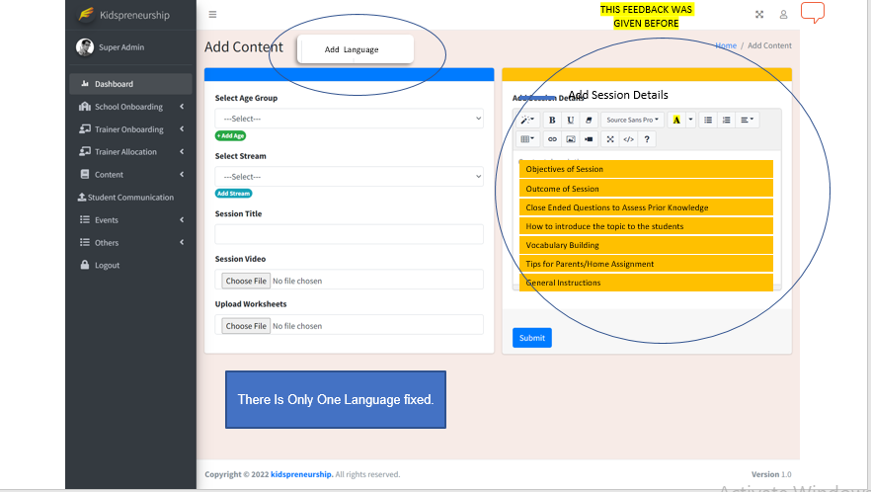

Slide no: 10-11.

In previous feedback you said change text area title description to “Add Session Details” that we changed already but in here you add this again. We can’t understand exactly what you want?

I want the text to be added under different headings and not just as a single block of text. I had explained this on the call. Below is the illustration of how the text will be added.

